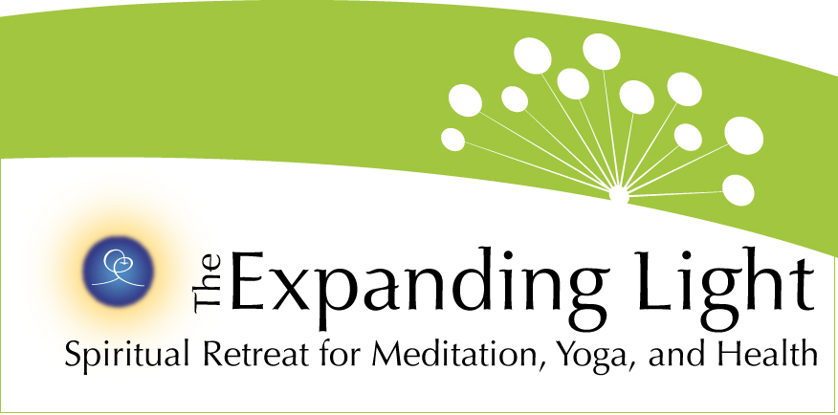

FOR IMMEDIATE RELEASE

CONTACT: Robert Yehling (917) 826-7880 • bob@wordjourneys.com
Gary Evans • garyje@hotmail.com

http://www.theyugasconference.com

GROUND BREAKING EVENT, THE YUGA CYCLES CONFERENCE,
TAKES PLACE MAY 25-28 IN NEVADA CITY, CA

ANANDA VILLAGE, NEVADA CITY, CA (March 5) – The Yuga Cycles of the Ages & Our Awakening Consciousness, a weekend of findings, presentations and discussions on ways the Yugas cyclical measurement of time has directly impacted the history of mankind, will take place May 25-28 and be hosted by The Expanding Light at Ananda Village, near Nevada City.
The conference, held in partnership with Ananda College of Living Wisdom, will bring together eminent scientists, educators, psychologists, geologists, yoga practitioners and spiritual leaders from around the world. They will address how the ancient wisdom of the Yugas and consequent discoveries relate to today’s acceleration of energy, technology and inner and outer understanding in fields, professions and individual lives.
“The focus of the conference will be on what I call the New Renaissance that is taking place today,” conference emcee Joseph Selbie, co-author of the groundbreaking book The Yugas, said. “Our New Renaissance is spurring a revolution in our understanding and practices around healing, psychology, and religion. The conference will explore emerging new scientific knowledge, and the ancient wisdom traditions that inspire and inform today’s teachers and scientific pioneers.”
Featured speakers include:
• Author and mind-body medicine pioneer Joan Borysenko;
• Quantum physicist Amit Goswami, featured in What The Bleep Do We Know;
• Ananda community founder Swami Kriyananda, author of more than 130 books;
• Scientist-educator David Steinmetz, co-author of The Yugas;
• Geologist/professor Dr. Robert Schoch, who re-dated the Great Sphinx’s age by thousands of years;
• Christopher Dunn, best known for his book, The Giza Power Plant;
• Claude Swanson, an expert on the scientific evidence for the presence of a discernible life force;
• Uma Krishnamurthy, practitioner and presenter of the ancient/modern synthesis called Yoga Psychology;
• Walter Cruttenden, producer of the successful CPAK Conference and The Great Year DVD, and author of Lost Star of Myth and Time;
• Conference emcee Joseph Selbie, co-author of The Yugas
The yugas (or ages) are part of a 24,000-year cycle of the development of human civilization and human awareness. Over 200 hundred mythic tales, found across 40 ancient cultures, include the lore of higher ages in the past. In the west we are most familiar with the Greek Golden Age, Silver Age, Bronze Age and Iron Age. In India the ages are called Satya Yuga, Treta Yuga, Dwapara Yuga, and Kali Yuga.
The Expanding Light Retreat, site of the conference and accommodations, is located in Ananda Village, approximately 75 miles northeast of Sacramento in the Sierra Nevada foothills. The non-profit retreat is open year-round and offers 120 programs in holistic health, meditation, and spiritual living. The retreat features various accommodation options, a professional vegetarian kitchen and highly acclaimed menu, and Center for Radiant Health, all within Ananda Village, an 800-acre intentional spiritual community.
Event partner Ananda College of Living Wisdom is the only college in the United States, and perhaps the world, that offers advanced curriculum in the Yuga Cycles of the Ages and Awakening Consciousness. The college features a standard curriculum plus four-year programs in Inspirational Arts, Yoga Philosophy and Sustainability, among others, and certificate programs in Yoga Teacher Training and Education for Life. Founded in 2003, it is located five miles from Ananda Village. A second campus will open in September, 2012 near Portland, Ore.
Registration for the event is underway. Seating and accommodations are limited to 180 people on a first-come, first-served basis. For more information on registration, go to http://www.theyugasconference.com or call 800-346-5350.

