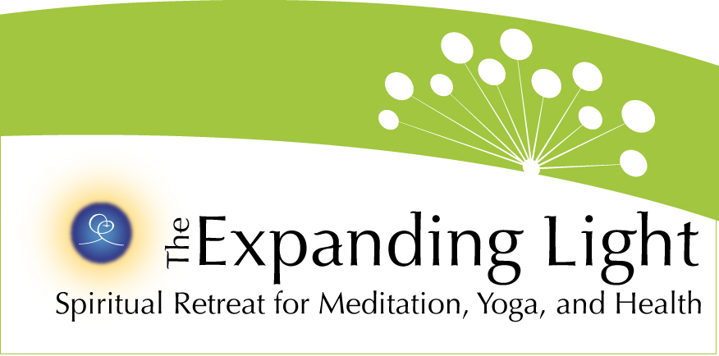

FOR IMMEDIATE RELEASE

CONTACT: Robert Yehling (917) 826-7880 • bob@wordjourneys.com
Gary Evans • garyje@hotmail.com
The Expanding Light: (800) 346-5350

http://www.theyugasconference.com

GROUND BREAKING EVENT, THE YUGA CYCLES CONFERENCE,
TAKES PLACE MAY 25-28 IN NEVADA CITY, CA

ANANDA VILLAGE, NEVADA CITY, CA (March 22) – The Yuga Cycles of the Ages & Our Awakening Consciousness, a weekend of findings, presentations and discussions on ways the Yugas cyclical measurement of time has directly impacted the history of mankind, will take place May 25-28 and be hosted by The Expanding Light at Ananda Village, near Nevada City.
The conference, held in partnership with Ananda College of Living Wisdom, will bring together eminent scientists, educators, psychologists, geologists, yoga practitioners and spiritual leaders from around the world. They will address how the ancient wisdom of the Yugas and consequent discoveries relate to today’s acceleration of energy, technology and inner and outer understanding in fields, professions and individual lives. The yugas (or ages) are part of a 24,000-year cycle of the development of human civilization and human awareness, and are correlated in 200 mythic tales, found across 40 ancient cultures.
Speakers include bestselling author Joan Borysenko, Amit Goswami (featured in What The Bleep Do We Know), Ananda founder Swami Kriyananda (author of 130 books), The Yugas co-authors David Steinmetz and conference emcee Joseph Selbie, Boston University geology professor Dr. Robert Schoch, Claude Swanson, Christopher Dunn, Uma Krishnamurthy and Walter Cruttenden, author of Lost Star of Myth and Time.
Registration for the event is continuing. Seating and accommodations are strictly limited to 180 people on a first-come, first-served basis. For more information on registration, go to http://www.theyugasconference.com or call 800-346-5350.

